“AeroCom Prescribed" Model/Satellite Intercomparison Study

Organisation:
Organisers
- Philip Stier (University of Oxford, UK)
- Stefan Kinne (Max Planck Institute for Meteorology, Germany)
- Gunnar Myhre (University of Oslo, Norway)
- Michael Schulz (Laboratoire Science Climat et de l'Enivonnement, France)
- John Seinfeld (California Institute of Technology, USA)
Contact: Philip Stier
Atmospheric, Oceanic and Planetary Physics
University of Oxford
Parks Road
Oxford, OX1 3PU
email: philip.stier@atm.ox.ac.uk
phone: +44 1865 272887
wiki: http://wiki.esipfed.org/index.php/AeroCom_Prescribed

Introduction
Aerosol radiative forcing estimates of global aerosol models and satellite retrievals show considerable diversity that can partly be attributed to differences in the aerosol radiative properties but partly also to processes and assumptions in the host models (e.g. surface albedos, clouds). The contribution of these host model processes to the total forcing uncertainty is entirely unclear. We propose a simple AeroCom model/satellite intercomparison study with prescribed aerosol fields that will facilitate their quantification.

Motivation
Even for the case of identical aerosol emissions, the simulated direct aerosol radiative forcings show significant diversity among the AeroCom models (Schulz et al., 2006). Our analysis of the absorption in the AeroCom models (Presentation at the 2006 AeroCom meeting , Poster at the AGU Fall Meeting 2006) indicates a larger diversity in the translation from given aerosol radiative properties (absorption optical depth) to actual atmospheric absorption than in the translation of a given atmospheric burden of black carbon to the radiative properties (absorption optical depth). The large diversity is caused by differences in the simulated cloud fields, radiative transfer, the relative vertical distribution of aerosols and clouds, and the effective surface albedo. This indicates that parameterisations differences in the host model (GCM or CTM hosting the aerosol model) contribute significantly to the simulated diversity of atmospheric absorption and consequently of the TOA forcing.
However, similar issues equally apply to total and anthropogenic aerosol radiative effects retrieved from satellite data. Recent retrieved forcing estimates, all based on the MODIS satellite data, show considerable diversity in the resulting aerosol radiative forcings. These diversities indicate that differences in radiative forcing calculations and the meteorological environment such as cloud structure, vapour field etc may contribute significantly to the diversity of the simulated and retrieved aerosol radiative forcing. The magnitude of these effects cannot be estimated from the diagnostics of previous AeroCom forcing experiments.
To quantify the contribution of differences in radiative forcing calculations in the context of the actual model environment (based on either global aerosol models or using satellite retrievals) to the estimated aerosol radiative forcing we propose a simple AeroCom experiment where prescribed aerosol property fields are introduced into the forcing calculation. The simulated forcing variability among the models and satellite retrievals is then expected to be a direct measure of the forcing calculation contribution to the uncertainty in the assessment of the aerosol radiative effects. “Forcing calculation” (and used furtheron for simplicity) is meant here to incorporate all factors such as radiative forcing code, albedo, cloud distribution, meteorological environment and any other process which could influence the calculation step from aerosol optical properties to aerosol radiative effect.

Experimental Setup
To quantify the contribution of differences in the “forcing calculation” to the simulated aerosol radiative forcing and atmospheric absorption estimates - from global aerosol models or observational based methods using satellite retrievals - the AeroCom Prescribed experiment is performed with prescribed identical aerosol radiative properties. Preindustrial and present day global 3D parameter distributions ( resolution 1°x1°) are provided to the participants as monthly-mean fields of aerosol extinction, single scattering albedo, and asymmetry factor. They were derived from the AeroCom median model and the AOD properties of these fields are illustrated in Figure 1:

a) | 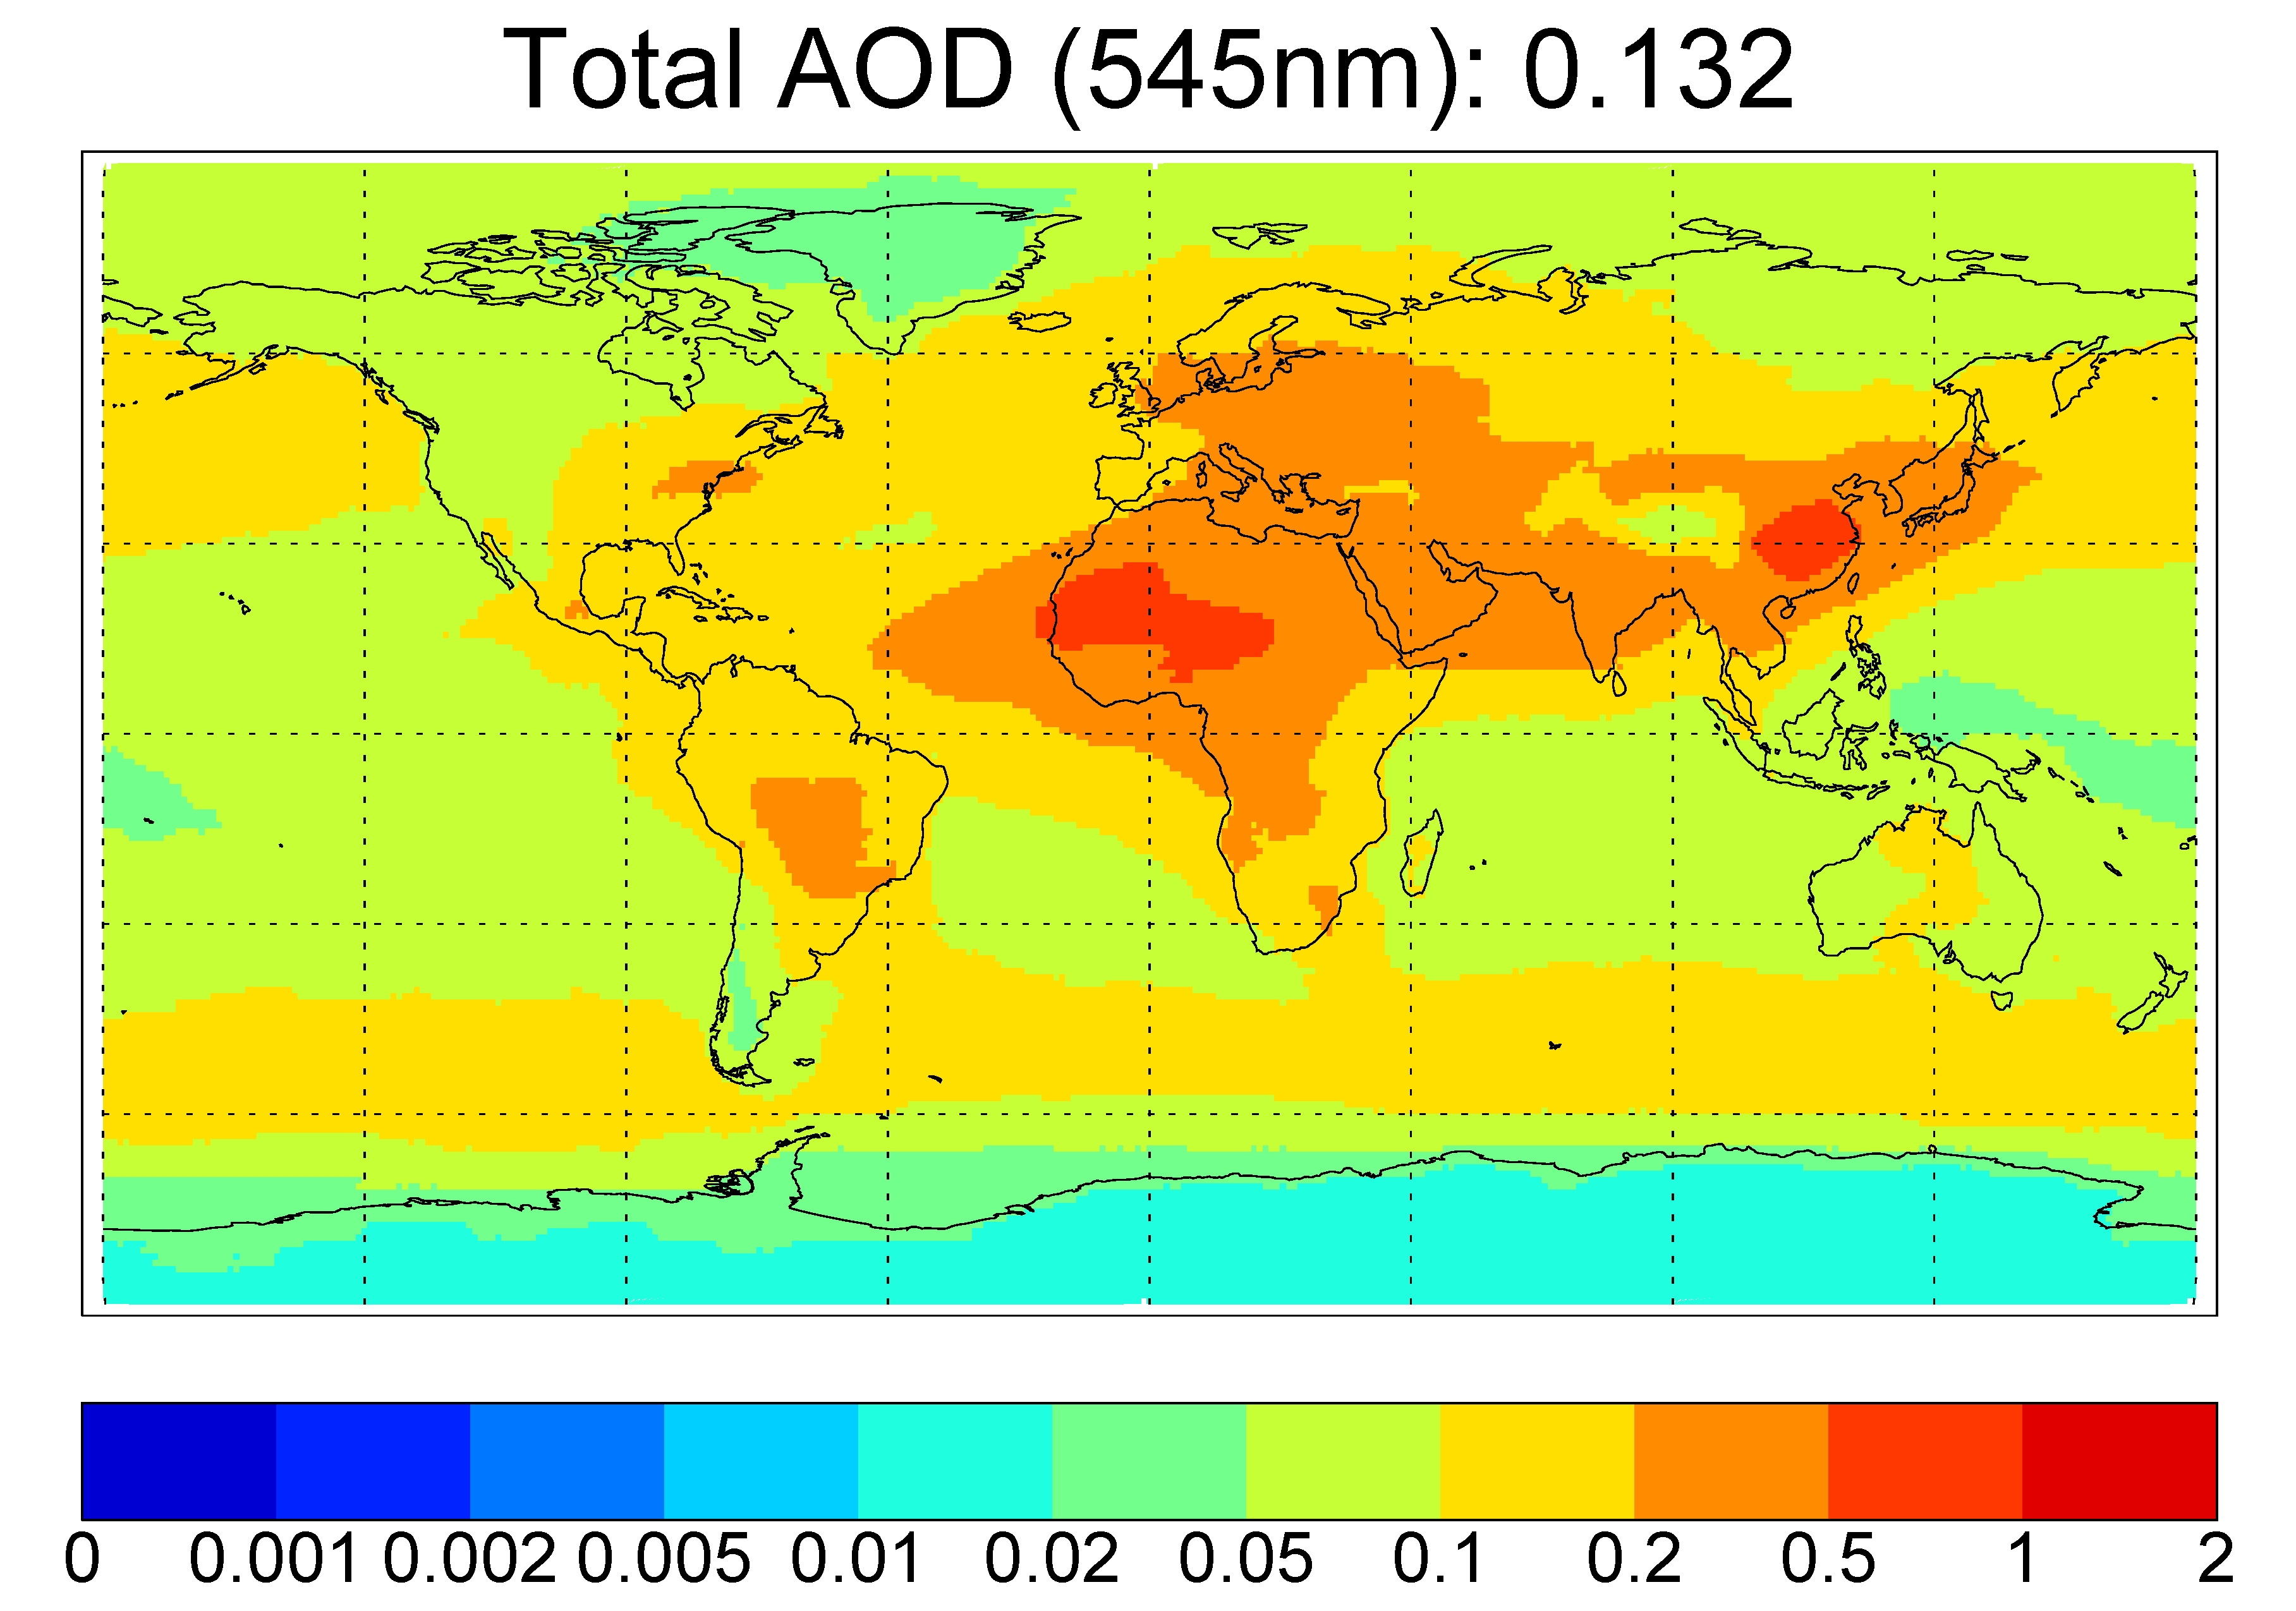 | b) | 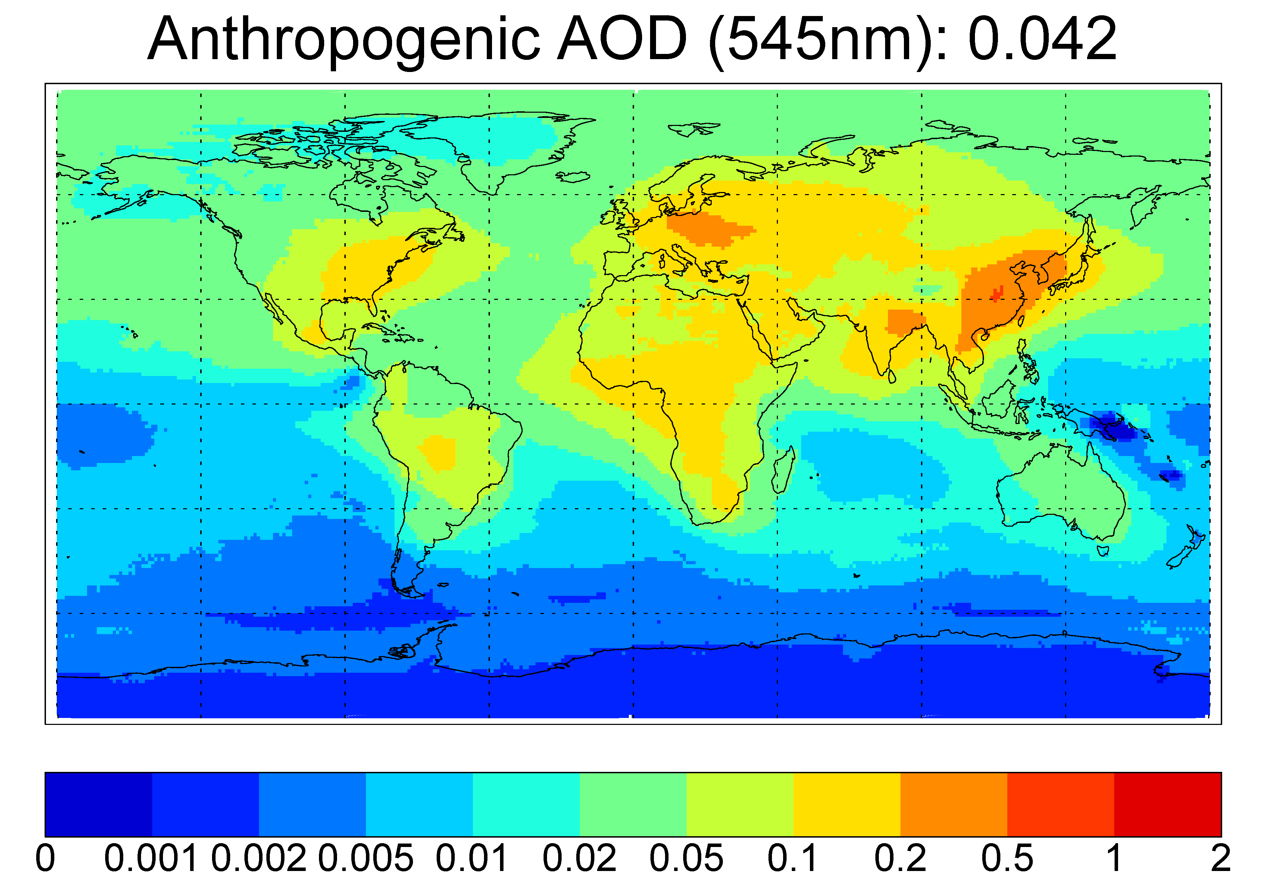
Figure 1: Example of the AeroCom Prescribed input data in form of a) total and b) anthropogenic aerosol optical depth at λ=545 nm.
These aerosol radiative property fields are made available on 24 SW bands that can be mapped to the bands of the individual host model radiation schemes. A weighting function will be provided.

The 3D fields of radiative properties need however to be interpolated by the participants to the respective model/retrieval resolution. (Interpolation tools will be provided based on cdo.)

These 3D monthly parameter fields should be read by the model and should replace the original values of the model during the execution of a simulation. This way the effective optical properties, which intervene in the radiative forcing calculation, can be also diagnosed through the standard model output procedure. Quality checks can then operate via the diagnostic output of the 3D aerosol fields, as implemented in each model, to ensure that the implementation of introducing aerosol fields has been as intended. Two one year experiments should be executed (preindustrial and present day) to obtain the anthropogenic forcing as difference of the TOA fluxes.

Based on this identical aerosol input data, participating models and satellite retrievals calculate the aerosol radiative forcing. For illustration figure 2 shows the result of an offline radiative transfer model using the prescribed aerosol fields. Models should ensure that the meteorological environment is not changed for the preindustrial and present day experiment. Aerosols do not feedback in the evolution of the meteorological environment in these experiments.

a) | 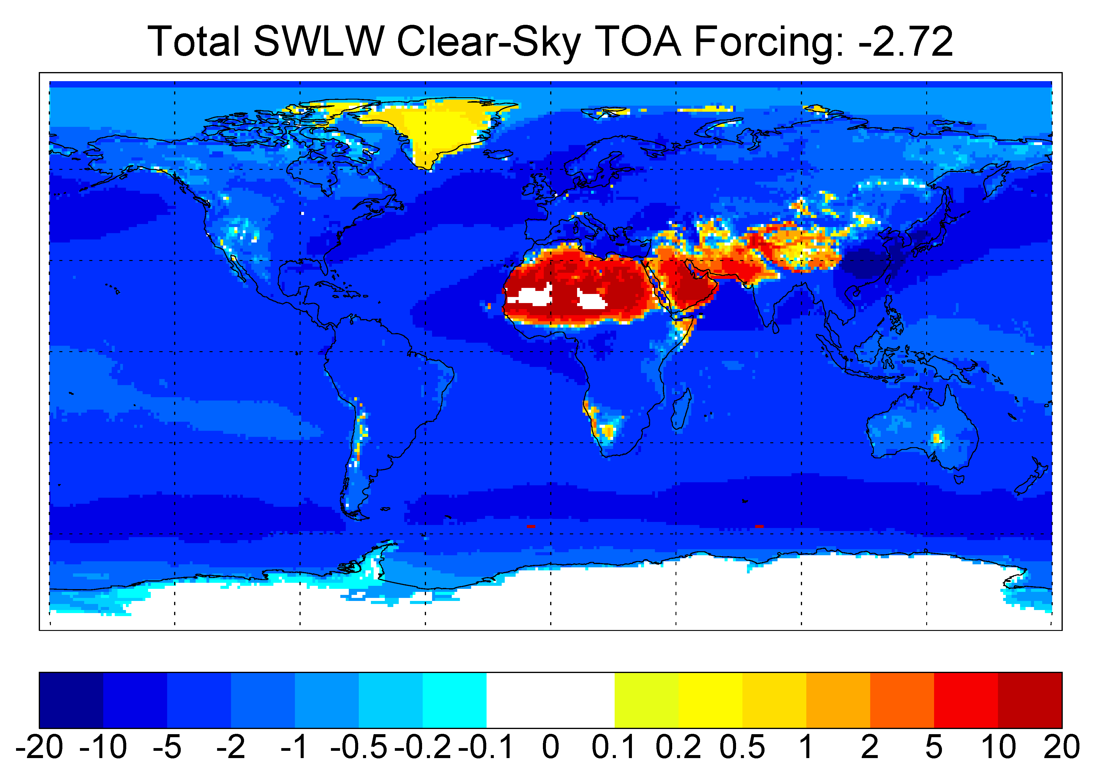 | b) | 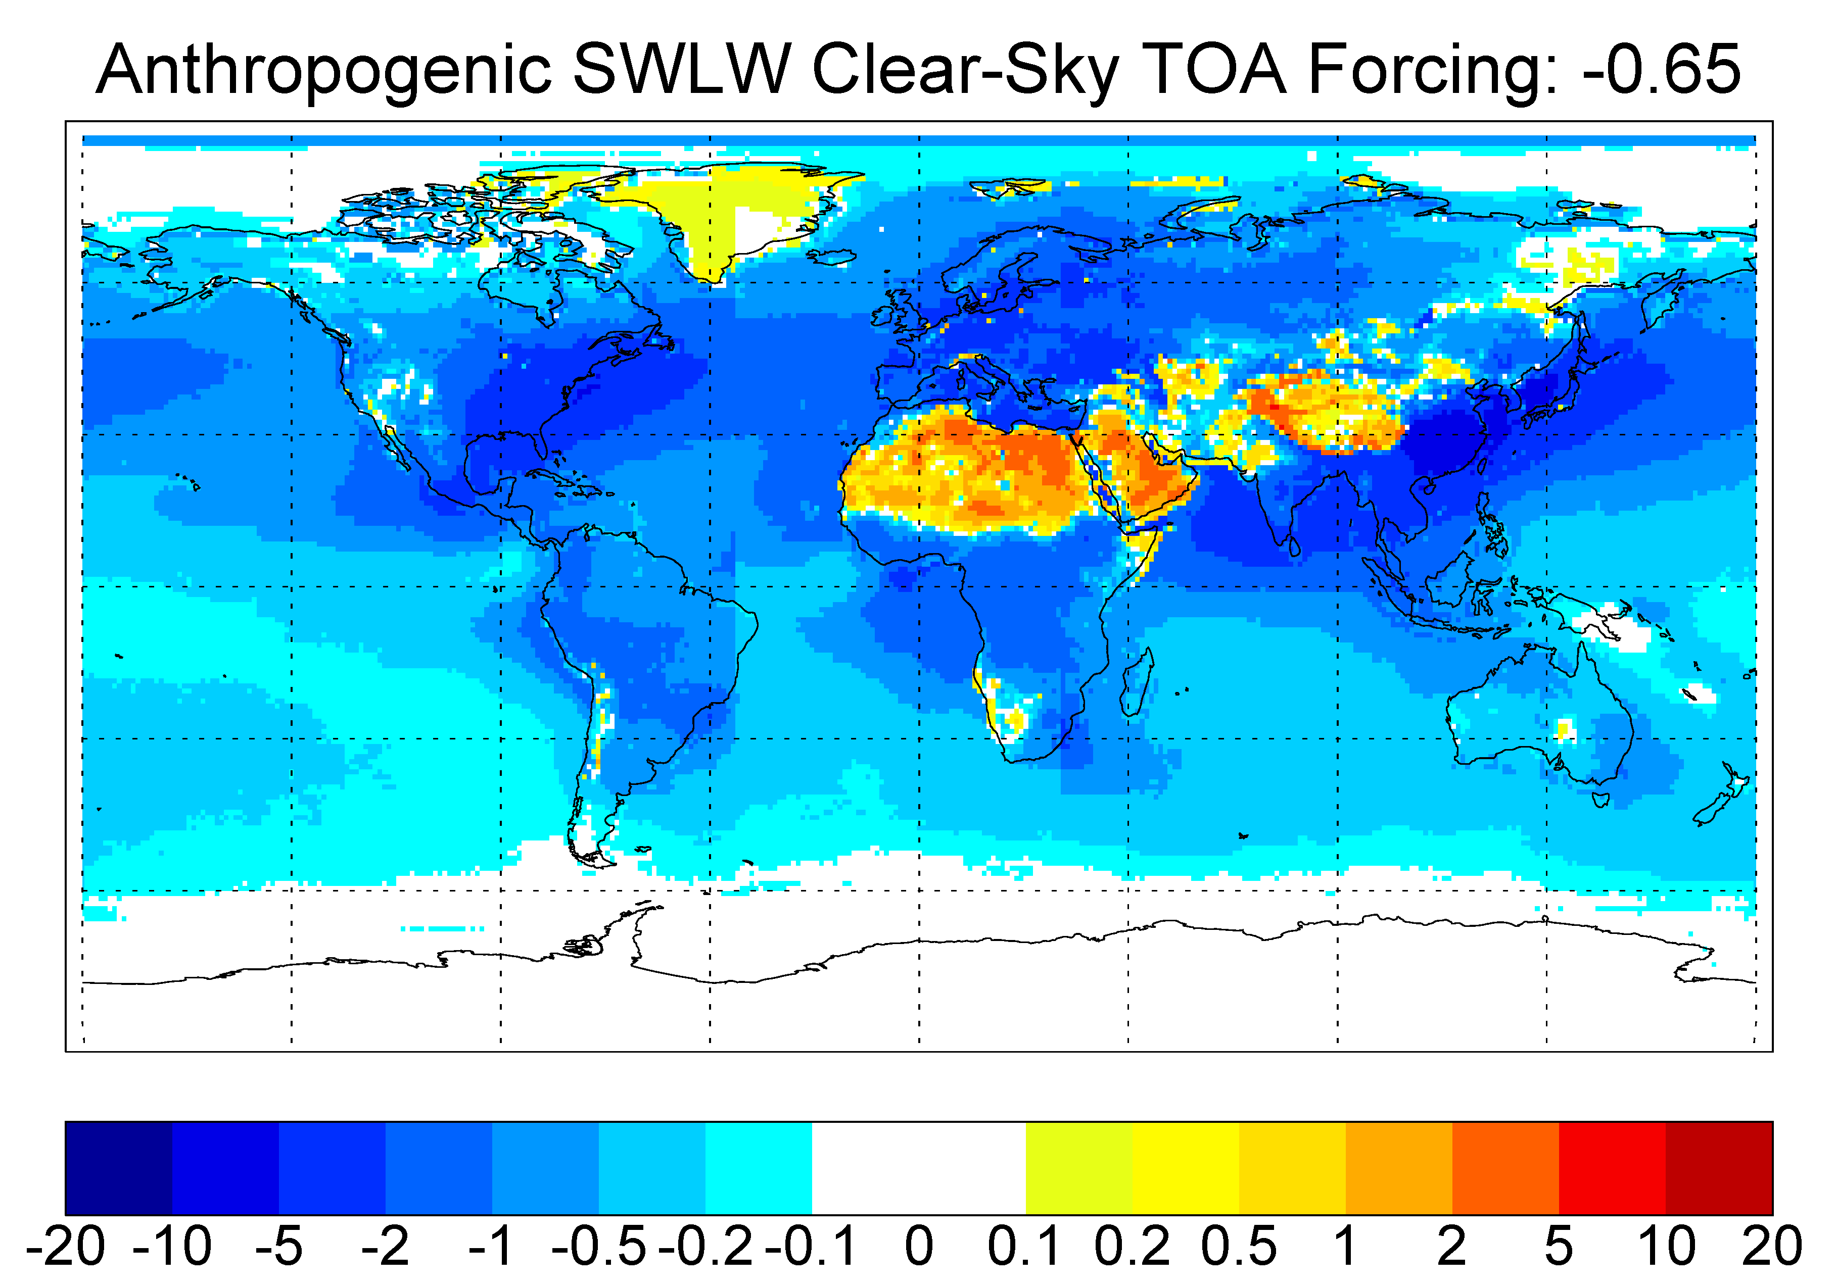
Figure 2: Resulting a) total radiative effect BUT THIS total “Forcing” requires a calculation without any aerosol, OR DO I GET SOMETHING WRONG HERE? and b) anthropogenic clear-sky top-of-atmosphere aerosol radiative forcing as derived with an offline radiative transfer model (Stefan Kinne, MPI for Meteorology).

Diagnostics (to be finalised)
All data needs to be submitted in netCDF format, following the CF convention and should be post-processed with the CMOR rewriting tool (http://www-pcmdi.llnl.gov/software-portal/cmor/). Specific CMOR tables for the AeroCom Prescribed experiment will be provided.

The diagnostics are summarized in an excel table, available via the AeroCom website:
http://nansen.ipsl.jussieu.fr/AEROCOM/AEROCOM_diagnostics.xls
Aerosols
- 3D aerosol radiative properties as implemented in the model (quality check)
- Separate diagnostics for cloudy sky and clear-sky radiative properties should be accumulated in the course of the simulation. If aerosols are neglected in the cloudy area fraction, submit fields as zero for cloudy sky forcings.
- ?
Clouds
- 3D fractional cloud cover
- 3D cloud optical depth
- ?
Radiation
- Forcing protocol as in the new AeroCom Forcing experiment and additionally:
- Upwelling and downwelling clear-sky and all-sky radiative fluxes at the top-of-atmosphere and at the surface for pre-industrial and present day periods – allows to derive effective surface albedo, including effects of snow cover, sun angles, etc.
- Explicit cloudy-sky and clear-sky aerosol radiative properties as applied in the model (i.e. zero if aerosols are neglected in the cloud fraction of a grid box)
- Optional: single column calculations for 1D aerosol profile, solar zenith angle, and surface albedo at few selected locations? (Benchmarking with reference radiation codes.)
- ?
General model parameters
- Prescribed surface albedo
- Information on radiation scheme (bands, key assumptions)
- ?

Schedule
The implementation of the experimental setup is simple and the results could guide future AeroCom experiments. Thus, we could propose a short timeframe of about 6 months:
Date | Task
03/2008 - 04/2008 | Interactive discussion and finalization of the diagnostic protocol
05/2008 - 08/2008 | Implementation stage and submission of results
03/09/2008 - 05/09/2008 | Special session at the AeroCom workshop in Reykjavik, Iceland
09/2008 - ? | Publication stage

Participation
Preliminary list of groups that indicated their participation:
Organisation | Model | Participant
Laboratoire Science Climat et de l'Enivonnement | LMDzT-INCA | Michael Schulz  Yves Balkanski
National Center for Atmospheric Research | CCSM3 | William Collins
UK MetOffice | HadGEM | Olivier Boucher  Nicolas Bellouin
University of Oslo | UiO_CTM | Gunnar Myhre
University of Oxford /  Max Planck Institute for Meteorology | ECHAM5-HAM | Philip Stier

